LED pg 24

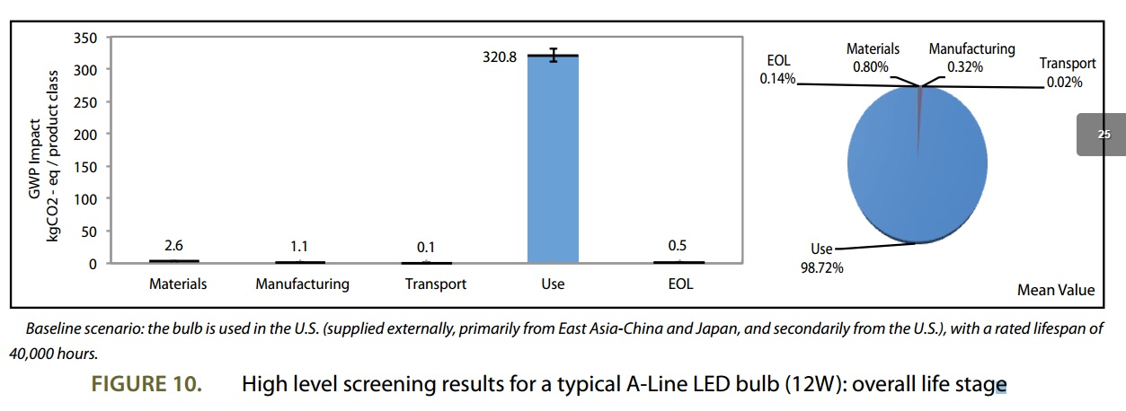

Source:

https://www.nema.org/Policy/Environmental-Stewardship/Documents/Carbon%20Footprint%20project%20%E2%80%93%20First%20Phase%20Report%20Sept%202012.pdf